**Experiment 5:** Create a simple cloud software application for Mark Sheet Processing System

using any Cloud Service Provider to demonstrate SaaS include the necessary

fields such as name of the student, Reg no of the student, Subjects , Marks,

Average, percentage, rank, overall performance etc.

Step 1: Creating a Application Form For Student Details

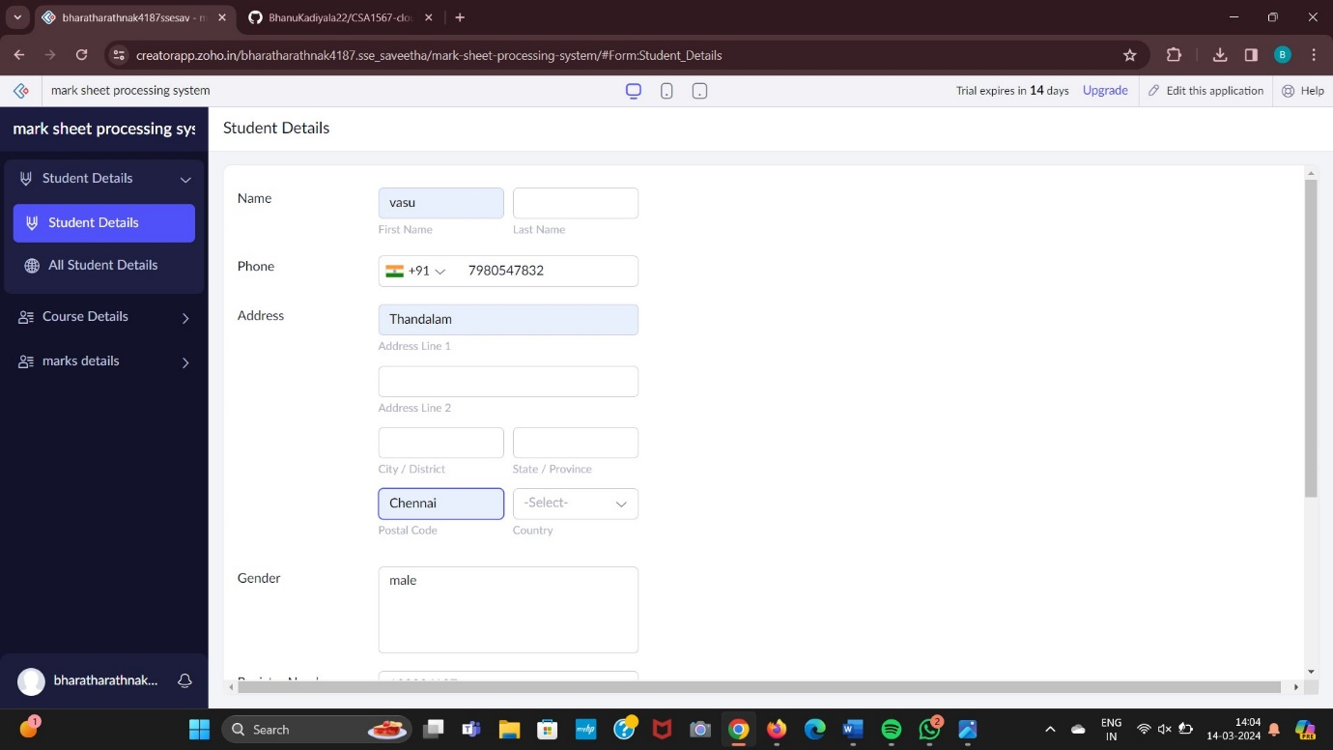

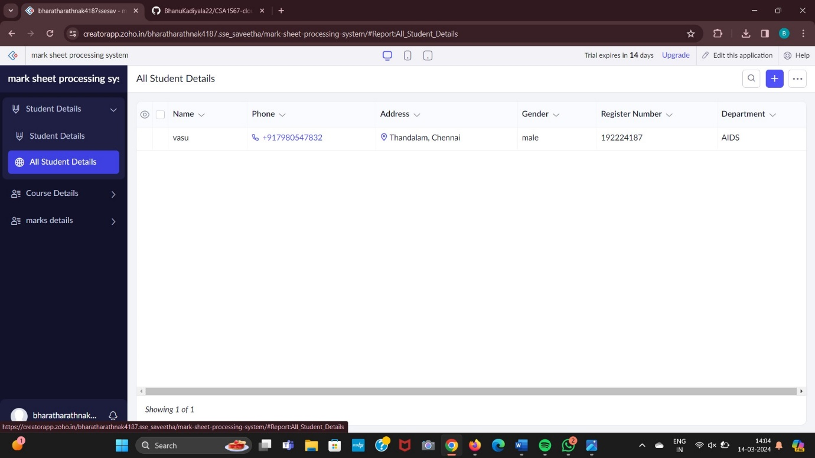

Step 2: Creating a Application Form For Course Details.

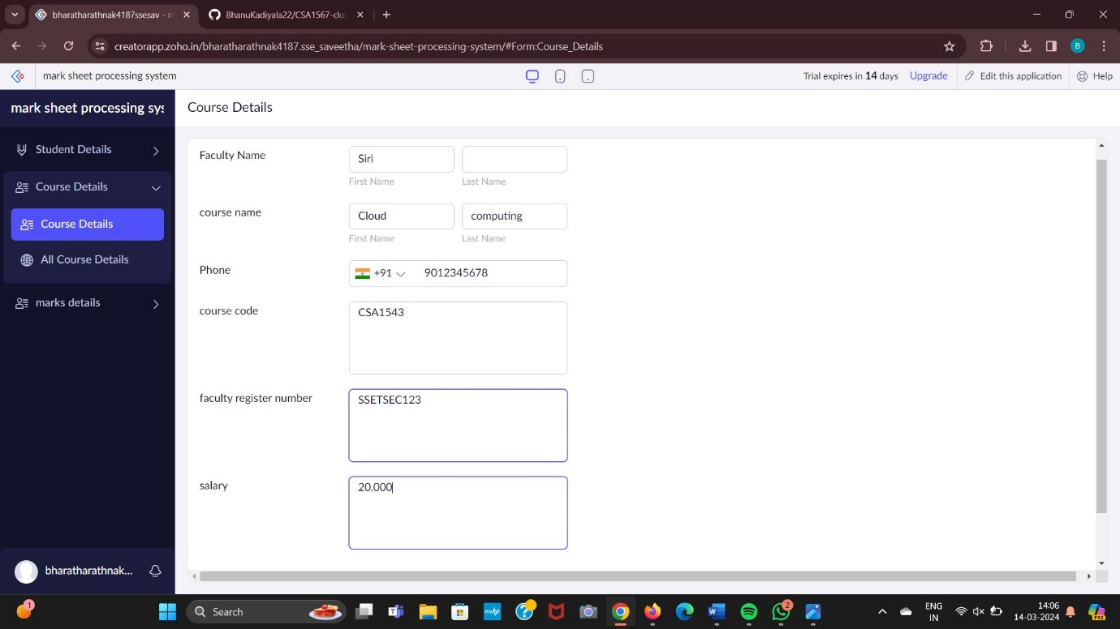

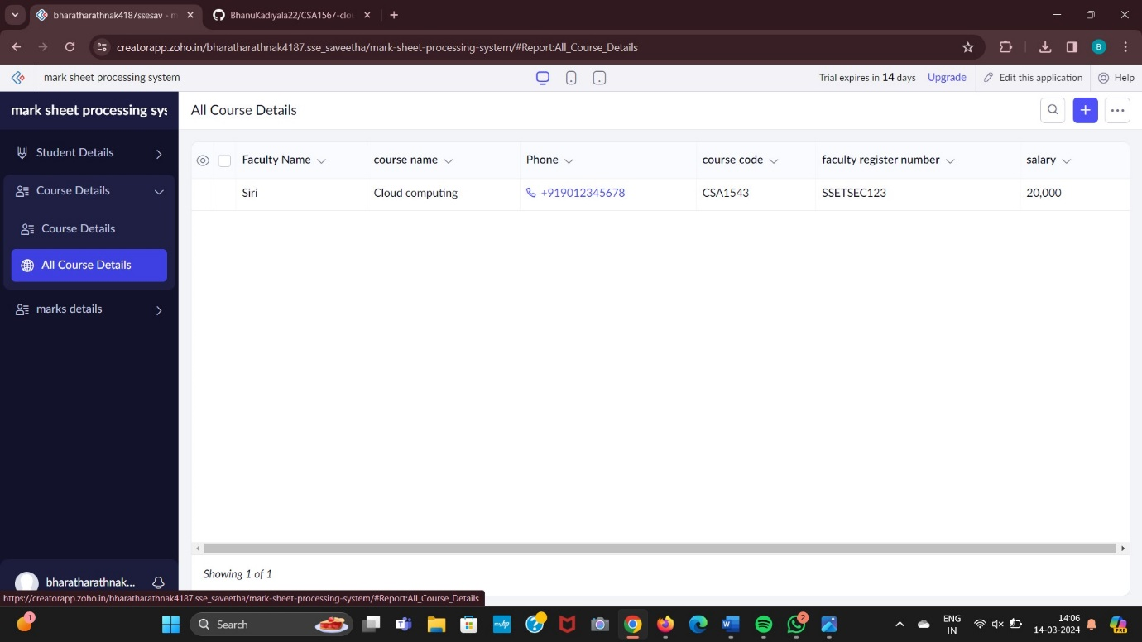

Step 3: Creating a Application Form For Marks Details.

